Bahria University,

Karachi Campus



LAB EXPERIMENT NO.

___11___

LIST OF TASKS

|  |  |
| --- | --- |
| TASK NO | OBJECTIVE |
| **01** | Retrieve the order year, month, product name, and calculate the total sales by multiplying the quantity and unit price of each order detail (using Northwind). |
| **02** | Perform the best suited technique such that the final result looks like this using Northwind |
| **03** | Create sample database then create the table given below and retrieve Salary by country along with grand total by rollup. |
| 04 | Write a query to retrieve Sum of Salary grouped by all combinations of the following  2 columns as well as Grand Total. Country, Gender by using cube. |

Submitted On:

07-06-2023

(Date: DD/MM/YY)

**Task 01:** Retrieve the order year, month, product name, and calculate the total sales by multiplying the quantity and unit price of each order detail (using Northwind)

perform the best suited technique such that the final result looks like this using Northwind.

**Solution:**

SELECT YEAR(o.OrderDate) AS OrderYear, MONTH(o.OrderDate) AS OrderMonth,

c.CategoryName, SUM(od.Quantity * od.UnitPrice) AS TotalSales

FROM Orders o

JOIN [Order Details] od ON o.OrderID = od.OrderID

JOIN Products p ON od.ProductID = p.ProductID

JOIN Categories c ON p.CategoryID = c.CategoryID

where YEAR(o.OrderDate)='1997' and c.CategoryName in ('Beverages','Condiments') and MONTH(o.OrderDate)=1

GROUP BY ROLLUP(YEAR(o.orderdate), MONTH(o.orderdate), c.CategoryName)

ORDER BY OrderMonth, OrderYear, c.CategoryName

**Output:**

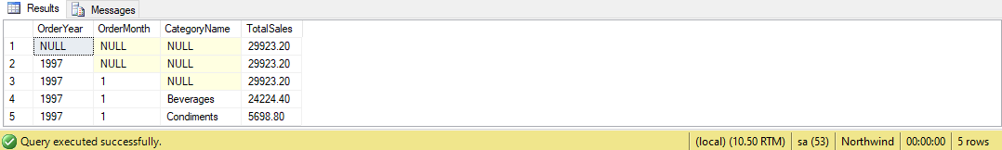

**Task 02:** Perform the best suited technique such that the final result looks like this using Northwind

**Solution:**

SELECT Categories.CategoryName, Orders.ShipCountry,YEAR(OrderDate) AS OrderYear, SUM([Order Details].Quantity * [Order Details].UnitPrice) AS TotalSales

FROM Orders

INNER JOIN [Order Details] ON Orders.OrderID = [Order Details].OrderID

INNER JOIN Products ON [Order Details].ProductID = Products.ProductID

INNER JOIN Categories on Products.CategoryID=Categories.CategoryID

GROUP BY cube (Categories.CategoryName , Orders.ShipCountry, YEAR(OrderDate)) order by Categories.CategoryName

**Output:**

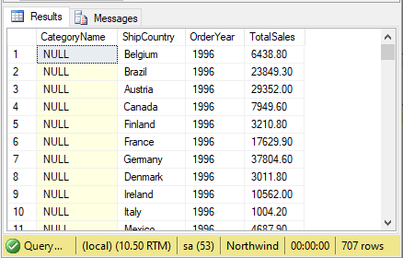

**Task 03:** Create sample database then create the table given below and retrieve Salary by country along with grand total by rollup.

**Solution:**

create database country

create table Employes(

Id int primary key,

Name varchar(255),

gender varchar(100),

salary int,

Country varchar(255),

)

insert Employes

values(1,'Mark','Male',5000,'USA')

insert Employes

values(2,'John','Male',4500,'India')

insert Employes

values(3,'Parn','Female',5500,'USA')

insert Employes

values(4,'Sara','Female',4000,'India')

insert Employes

values(5,'Todd','Male',3500,'India')

insert Employes

values(6,'Marry','Female',5000,'UK')

insert Employes

values(7,'Ben','Male',6500,'UK')

insert Employes

values(8,'Alizabeth','Female',7000,'USA')

insert Employes

values(9,'Tom','Male',5500,'UK')

insert Employes

values(10,'Rohn','Male',5000,'USA')

select Country,SUM(salary) as TotalSalary from Employes group by rollup(Country)

**Output:**

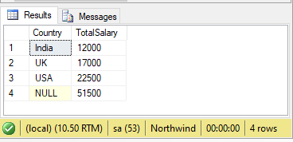

**Task 04:** Write a query to retrieve Sum of Salary grouped by all combinations of the following

2 columns as well as Grand Total. Country, Gender by using cube.

**Solution:**

select coalesce(Country,null,'total') as Country ,coalesce(gender,null,'total') as Gender, SUM(salary) as TotalSalary from Employes group by cube(Country,gender) order by Country,gender

**Output:**

